**Software Requirements Specification**

**For**

**My PerFit Life**

**Version 1.0 approved**

**Prepared by Dan Citardi, Payal Narkhede,**

**Ankit Singh, and Erin Stansbury;**

**Pace University;**

**26 November 2018;**

Table of Contents

Revision History

1. **Introduction** 
   1. Purpose
   2. Document Conventions
   3. Intended Audience and Reading Suggestions
   4. Product Scope
   5. References
2. **Overall Description**
   1. Product Perspective
   2. Product Functions
   3. User Classes and Characteristics
   4. Operating Environment
   5. Design and Implementation Constraints
   6. User Documentation
3. **External Interface Requirements** 
   1. User Interfaces
   2. Hardware Interfaces
   3. Software Interfaces
   4. Communications Interfaces
4. **System Features**
   1. System Feature 1
   2. System Feature 2
5. **Other Nonfunctional Requirements**
   1. Performance Requirements
   2. Safety Requirements
   3. Security Requirements
   4. Software Quality Attributes
   5. Business Rules
6. **Other Requirements**

**1. Introduction**

**1.1 Purpose**

My PerFit Life is a mobile application intended to improve the health and fitness of its users. It gives its users a practical, convenient, and easy to use tool for tracking their fitness progress. This mobile application tracks the user’s steps and records their progress over time. The user can add a distance goal which aids in user motivation. This is the Version 1.0 with expected updates and new versions to follow. More details pertaining to newer versions can be found under the Product Scope in 1.4.

**1.2 Document Conventions**

My PerFit Life may be referred to throughout this SRS as the *mobile application, app,* or *product.* Unless otherwise specified, the application in mention refers to Version 1.0.

**1.3 Intended Audience and Reading Suggestions**

This document is intended for developers, project managers, and testers to refer to while in production, QA testing, or to ensure all acceptance criteria has been met before deployment. The reader should begin with the Introduction and Overall Description. After becoming familiar with the overall product of My PerFit Life, the reader should then progress into the more technical requirements further on in the SRS in order to better understand them.

**1.4 Product Scope**

My PerFit Life is a mobile application for Android developed in Java. The objective of the application is to track users’ steps while motivating them to lead a healthier, more fit lifestyle. One goal of the application is to expand from a solo user experience to one that integrates a social aspect. One study developed an application that allowed users to choose whether they would prefer to track an individual exercise or compete with someone else on the app. “Results show that users significantly enhanced physical activities using HealthyTogether (the test application) compared with when they exercised alone by up to 15%” [1].

In terms of corporate goals and business strategies, the application will be released to the app store for $.99 per download. There will be ad space sold within the application in order to generate more revenue. Users may purchase an upgrade to a version that is ad-free for an additional $.99 per year. A more detailed version of My PerFit Life’s scope can be found in the Feasibility Analysis.

**1.5 References**

[1] Chen, Yu, and Pearl Pu. "HealthyTogether: exploring social incentives for mobile fitness applications." Proceedings of the second international symposium of chinese chi. ACM, 2014.

**2.** **Overall Description**

**2.1 Product Perspective**

My PerFit Life was developed for anyone with any level of interest in fitness. This application will have features that are important and useful to all individuals regardless of experience. Whether a user has been an fitness guru for a while or just beginning their quest to a healthier lifestyle, My PerFit Life will be able to help.

We will have an active team of developers that will look to consistently gather feedback from all different users and continue to enhance the product to best suit our loyal users. It is currently being developed for Android, but will expand to Apple devices in the near future.

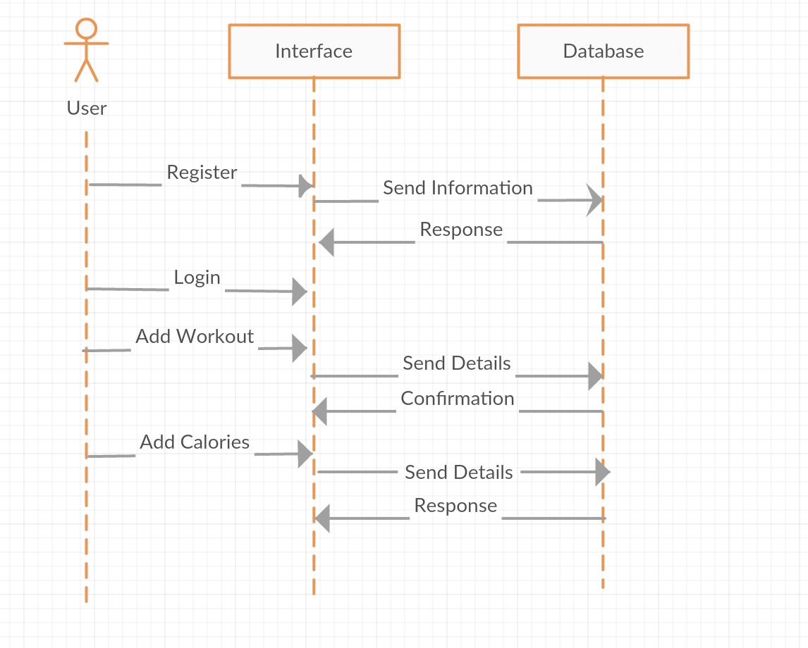

**2.2 Product Functions**

With the mobile application, a new user can create an account and after that the user can login into the account. After that the user can access the application and the user will update his/her details. After that the user can enter workout or he/she can get nutrition advice from any fitness coach and the user can challenge other users and friends. User can access the calories count and

steps count and many more features.

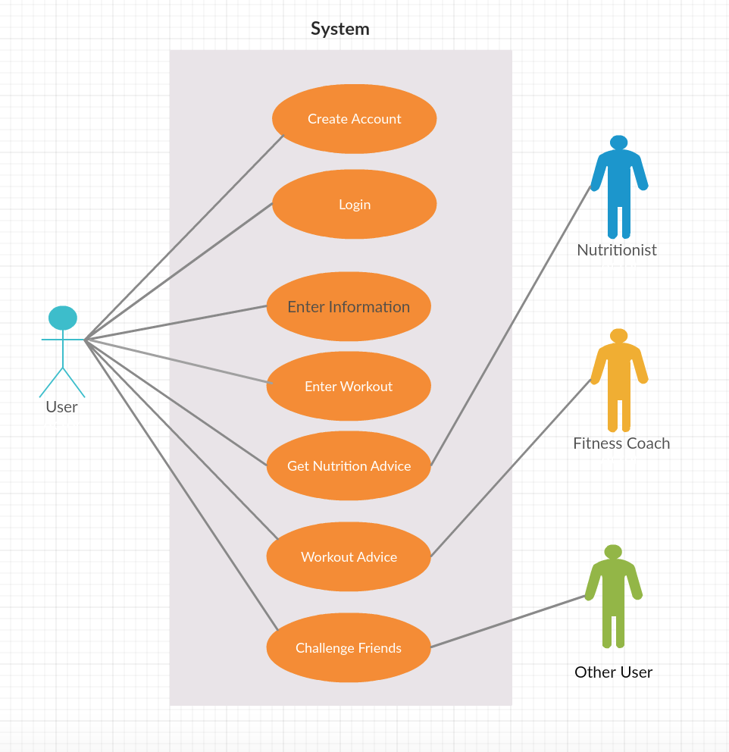

**2.3 User Classes and Characteristics**

My PerFit Life will appeal and be of use to all individuals in the fitness community. Whether a user is a fitness guru, or someone who just simply wants to keep track of their daily steps, this app will be of use to them. Any user regardless of age will be able to take full advantage of our product. Some users who are more focused on their dietary habits may look to use our calories feature whereas users who are less concerned may not make use of this feature.

**2.4 Operating Environment**

MyPerFit Life was developed using Java within Android Studio. Version 1.0 of My PerFit Life is only available for Android devices, following versions of the application will be available for iOS.

**2.5 Design and Implementation Constraints**

In order to calculate the user’s steps, the application must have access to the device’s GPS and/or the device’s internal pedometer located on the *Health* application.

**2.6 User Documentation**

For User Documentation, My PerFit Life will have an online help section dedicated to answering any user questions or instructions about the application. The help section will include a breakdown of terminology, Frequently Asked Questions (FAQ), as well as a contact form too. My PerFit Life will also have a community forum where users can ask questions outside of the typical ‘Frequently Asked Questions’. This community forum will also be a tab found on the application in future versions. There, users can share their progress, ask questions to other My PerFit Life users, and continue on their fitness journey with supporters online in order to increase their motivation.

**3. External Interface Requirements**

This section provides the description of user, hardware, software and communication interfaces of the system. This section gives the detailed description of the input and output characteristics of the system.

**3.1 User Interfaces**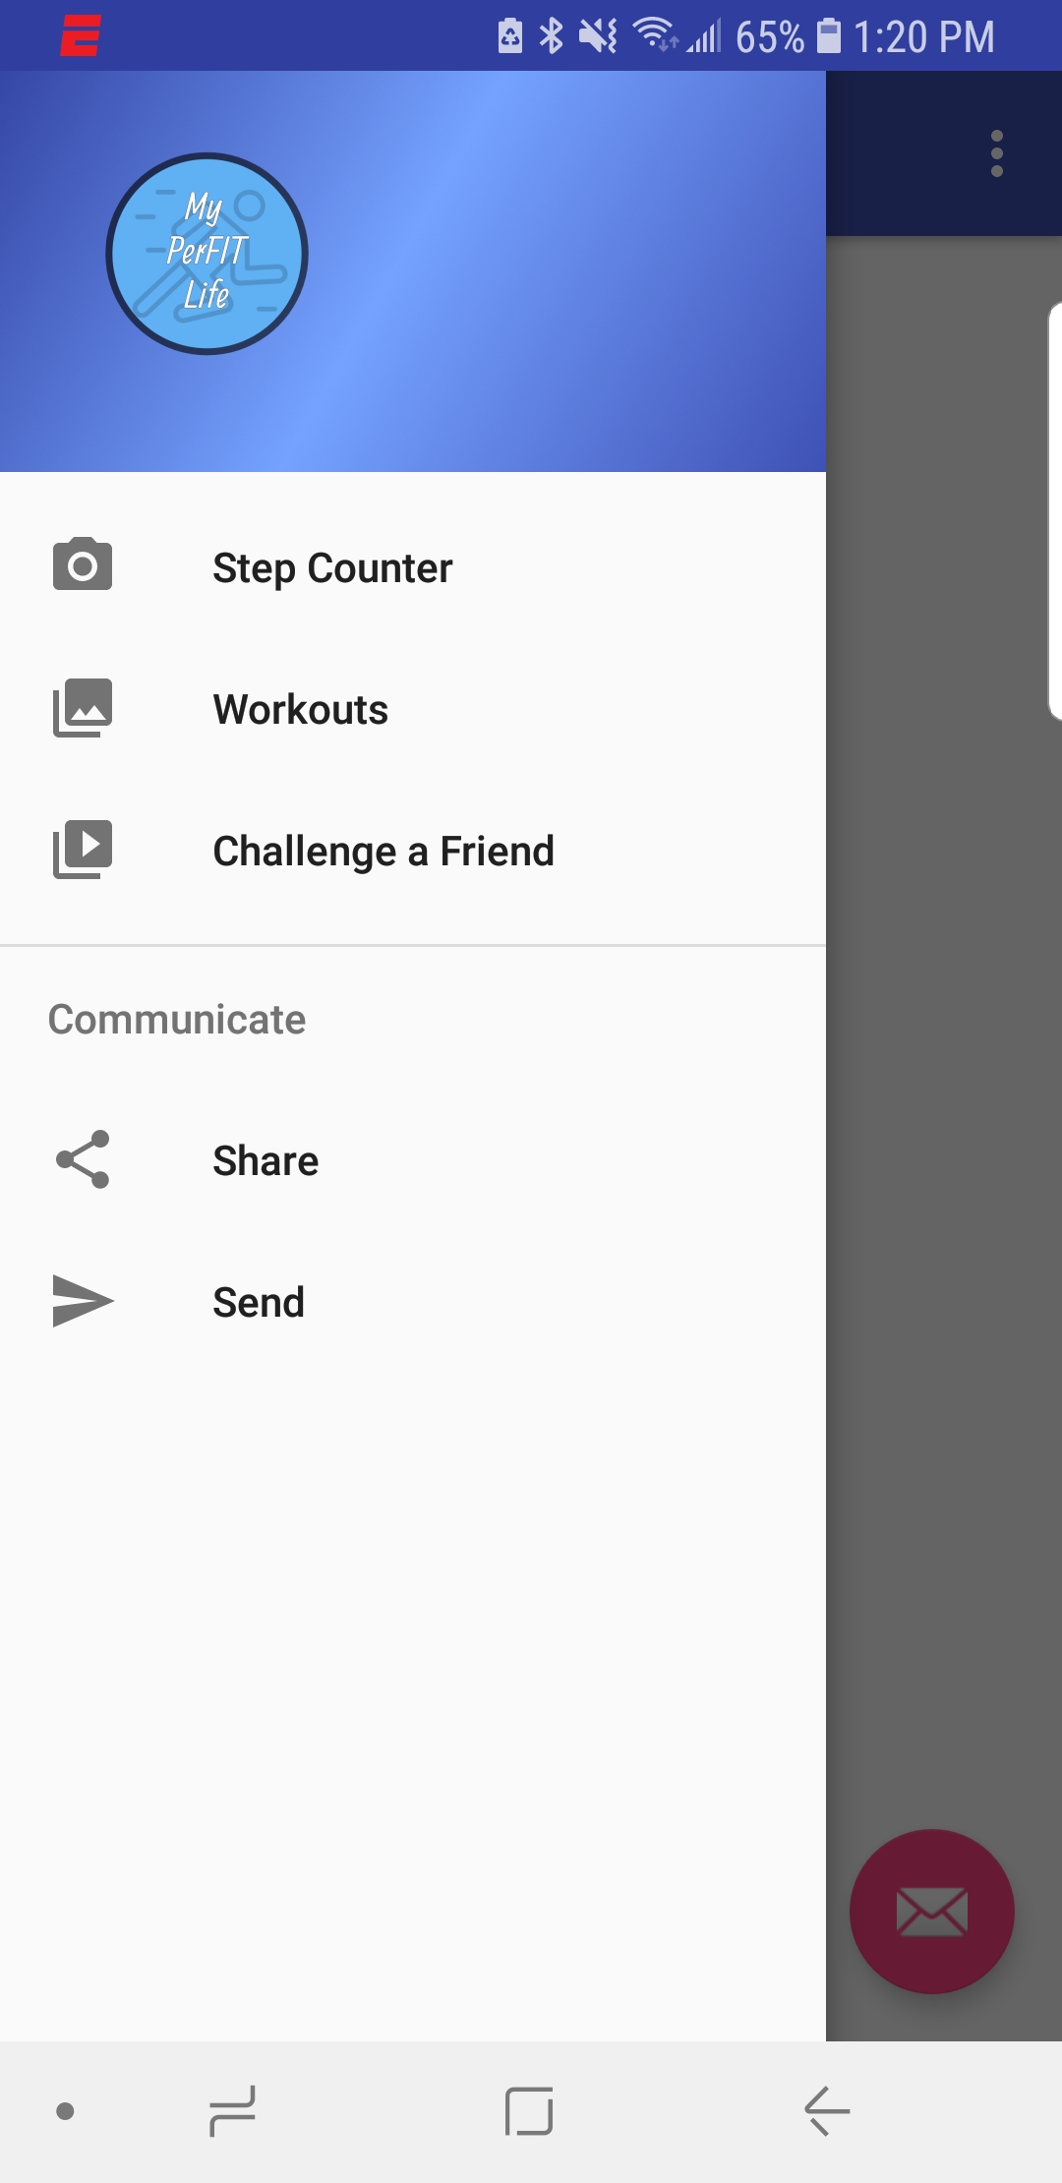

When a user accesses the mobile application for the first time, user will be presented with a page to either login or register. If the user has not yet registered for an account, they should click on the “Register” button to be taken to a new page where they are able to register. The registration page will require a name, email, password, height, and weight. After clicking the register button on that page, if all the fields are entered, an email confirmation will be sent to the entered email addresss. If a user has already registered for an account, they should be able to enter their email and password and log into their account. There will also be a “rememberMe” checkbox available to press so the user doesn’t have to type in their information every time the application is loaded.   
   
After a successful login, there will be 30 second advertise to watch and user will be able to take the tour of the application.

Once logged into the application, the user will be taken to a home page. All of the different screens and activities accessible to the user will all be conveniently placed in a navigation drawer. From there, the user can click on any of the following tabs: step counter, workouts, and challenge a friend.

The step counter will be the main screen. On this screen, we will show the user their daily step counts. Based on the step counts, the user will also be able to see the calories burned and how much distance they travelled in the day. This feature will look to take advantage of the built in system GPS and allow for tracking of distance covered. The calories burned takes into account a basic formula that states that every 20 steps taken is the equivalent of one calorie burned. We will look to expand these features in the future to provide more individuality to each user.

By clicking on the Workout tab, the user will be able to input their workouts into a list for easy and convenient access. The user have the option to press a button to “Add a Workout” and they will be able to input how many miles they have completed. The information will be stored in the database to allow for a build up of the list to see how much progress is being made over time. 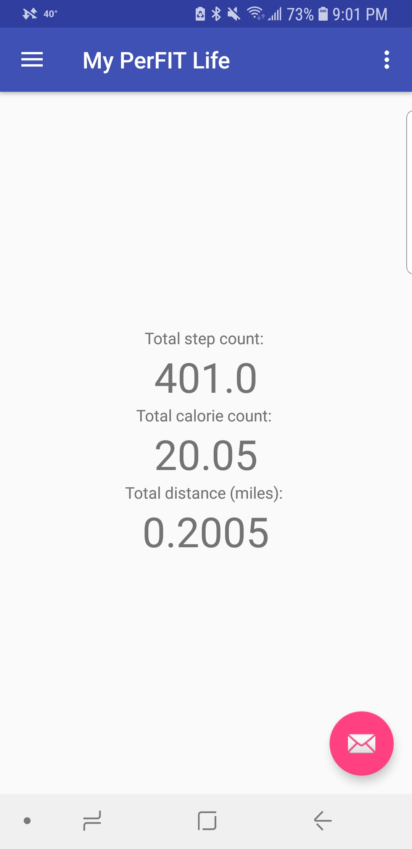

The “Challenge a Friend” tab is quite simple. A user clicks on the tab and then the application will load up the default SMS app on the Android device. From there, the user will be able to click on a contact and the the text field will be loaded up with a predetermined message saying that they have been challenged to a fitness competition and include a link to download our application.

**3.2 Hardware Interfaces**

For outside hardware interfaces, we would like to connect our application with various Smart Watches, such as the Samsung Gear Watch. Doing this will increase the portability of our application and will also allow users to have the application more readily available. Many individuals don’t necessarily run with their phones, so having this feature on the watch will still allow them to make use of all the features.

**3.3 Software Interfaces**

MyPerFit Life is developed in Java and will make use of the Android Studio IDE. The application will be developed in the latest version of Android Studio.   
  
MyPerFit Life application will need the database to store the user’s workout data. Administrators will be allowed to access the database to analyze and modify the user’s data. MyPerFit Life userswill be able to only read the information from the database.

**3.4 Communications Interfaces**

MyPerFit Life application will need Internet connection to update the software and find the friends for group exercise.  
  
The system needs to form the connection between the device and mobile application by Bluetooth or by Wi-Fi to transfer the workout data.

Our system will use the Google Firebase Database to store all of our information. Google Firebase allows for easy implementation into Android Studio and our application. Built into Firebase is a system of authentication that allows users to register through the use of email and a password and then it generates a unique userID for each person that registers. This ID will be our way of connecting all the information on a person’s app to the database itself and will allow for more information to be constantly synced.

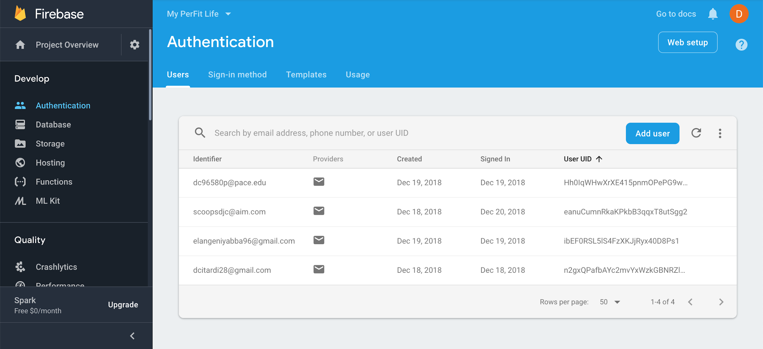

**4. System Features**

This section includes the functional requirements of the software system by system features and major services provided by the system. The functional requirements are organized and prioritized by their importance.

**4.1 Functional Requirements**

### **4.1.1 User Requirements**

**ID: REQ-1**

TITLE: Downloading MyPerFit Life mobile application

DESC: When users search for the MyPerFit Life application, the results should take them to landing page. The landing page gives users the option to look at description, info, screen shots, supportability, and Permissions. Through the Google Play Store, the user should be able to download the MyPerFit Life fitness application.

RAT: For a user to download the mobile application.

PRI: 5

DEP: None

**ID: REQ-2**

TITLE: Registration of the user

DESC: Upon accessing the mobile application, the user should be able to register the account by providing a name, email, password, height, and weight

RAT: To register user in mobile application.

PRI: 5

DEP: REQ-1

**ID: REQ-3**

TITLE: User Log-in

DESC: Once the registration is done, the user’s information is stored in the database. If a registered user tries to access the account, then the user should be able to log in through his credentials

RAT: To log-in into the mobile application.

PRI: 5

DEP: REQ-2

**ID: REQ-4**

TITLE: Registered user tries to register again

DESC: Upon registering in the application, if a registered user tries to register again, then they should be taken to the login page saying user is already registered. If a user is trying to register with the different email, then they should be able to register the account again.

RAT: To log-in into the mobile application.

PRI: 3

DEP: REQ-2, REQ-3

**ID: REQ-5**

TITLE: Unregistered user tries to log-in.

DESC: If an unregistered user tries to login into the application, there system should alert the user that there is no account found with this email

RAT: To log-in into the mobile application.

PRI: 3

DEP: REQ-2, REQ-3

**ID: REQ-6**

TITLE: Retrieve user’s password.

DESC: If a registered user forgot his/her password, then the user should be given the option to retrieve the password by giving his email. The password retrieve link should be sent to the user’s email so the password can be reset

RAT: To retrieve the password for log-in to the application.

PRI: 4

DEP: REQ-2, REQ-3

**ID: REQ-7**

TITLE: Present with the advertisement.

DESC: After a successful login into the application, the user should be presented with the a 30 second advertisement if they have the free version.

RAT: None (In order to get the source income)

PRI: 5

DEP: REQ-3

**ID: REQ-8**

TITLE: Form user’s profile.

DESC: When a user registers and logs into to the system, then the user should be asked a series of questions to form the user’s profile. This profile should include their personal information such as height, weight, gender, cardio and physical measurements.

RAT: In order to form the user’s profile for further analysis.

PRI: 4

DEP: REQ-3

**ID: REQ-9**

TITLE: Home screen- workout page

DESC: Once the user is logged-in to the mobile application, User should be able to see the workout page. The workout page should contain following information: covered distance in miles/Km, step count, calories burned, calories intake and total calories.

RAT: The way workout-page from home screen should be displayed.

PRI: 5

DEP: REQ-3

**ID: REQ-10**

TITLE: Home screen - goals met.

DESC: On the home screen with workout information, the user should be able to see how many days in the week they met his workout goals. The information should be displayed in the star format.

RAT: The way met goals should be displayed.

PRI: 1

DEP: REQ-3, REQ-9

**ID: REQ-11**

TITLE: Add/delete workout.

DESC: After selecting the add/delete workout icon, the users shall be presented with a page that lists the dates of recent workouts either in the form of a drop-down list or a scroll box.

RAT: To manage the workout.

PRI: 2

DEP: REQ-3

**ID: REQ-12**

TITLE: Edit workout goals

DESC: After selecting the edit workout tab, user should be able to edit his daily workout preferences.

RAT: To allow user to edit his workout type.

PRI: 1

DEP: REQ-3

**ID: REQ-13**

TITLE: Progress page

DESC: When a user selects the progress page, the user should be able to see the progress from his previous workouts.

RAT: In order to allow user to see his workout progress.

PRI: 1

DEP: REQ-3, REQ-9

**ID: REQ-14**

TITLE: Create Group Competition/Workout.

DESC: A user should be able to create a group competition. A user should be able to search for the other user who is registered in the mobile application and start the workout. Opponents should be able to accept the workout request.

RAT: To start the group competition/workout.

PRI: 3

DEP: REQ-3, REQ-9

### **4.1.2 System Requirements**

**ID: REQ-15**

TITLE: Transfer workout data from device to database.

DESC: System shall connect with the device wirelessly by using Wi-Fi or Bluetooth connectivity. After securing a connection, the system should sync the data with the database

RAT: To sync the data with the database

PRI: 5

DEP: REQ-3

**ID: REQ-16**

TITLE: Keep database for all users.

DESC: The system shall be able to keep a database for all the users. Only the administrator should be given permission to access the database. The database should contain all personal and workout information of the user. The database should contain the email, hashed password, height, weight, and workouts.

RAT: To access all the user’s information.

PRI: 5

DEP: REQ-3, REQ-9, REQ-15

**ID: REQ-17**

TITLE: Calculate average calories burned.

DESC: The system will have the database to analyze the workout data. The system should calculate burned calories using the formula, 20 steps = 1 calorie burned. User will be provided with the tab in which he can add what food he ate till end of the day. As per his food intake, calorie intake will be calculated. For example, for 1 piece of meat pizza slice the calories intake will be 310. At the end of the day, the system should be able to calculate average calories burned by using the mathematical formula which is, average calories burned = calories burned – calorie intake.

RAT: To calculate user’s average calories burned.

PRI: 4

DEP: REQ-3, REQ-9, REQ-16

**ID: REQ-18**

TITLE: Determine the winner of group competition/workout.

DESC: The system should be able to analyze the workout data from group competition to determine the competition winner. The system should show the results from the competition to allow the users to analyze the data.

RAT: To see the result of the group competition.

PRI: 3

DEP: REQ-3, REQ-9, REQ-14

### **4.1.3 Administrator Requirements**

**ID: REQ-19**

TITLE: Create/register the account.

DESC: The administrator should be able to register and log-in to the system by using username, password. The administrator should be able to form their profile with their personal details and be given access to the database.

RAT: In order to log-in to the system.

PRI: 5

DEP: None

**ID: REQ-20**

TITLE: Permission to access user’s details.

DESC: Administrators shall have full permission to access the user’s account details. Administrator should be able to maintain the database.

RAT: In order to access the user’s account.

PRI: 5

DEP: REQ-19, REQ-9

**ID: REQ-21**

TITLE: Delete user’s account.

DESC: In case of non-responsiveness or for security purposes, the administrator should able to retire the user’s account from the system. Administrator shall be responsible for deleting all user’s information from the database.

RAT: In order to delete the user’s account.

PRI: 1

DEP: REQ-19

**5. Nonfunctional Requirements**

**ID: REQ-22**

TITLE: Permission to access the database.

DESC: The user’s workout data and personal information should be stored in database. A user should not be able to directly modify any workout data from the database directly. Only the administrator should be allowed to access/modify user’s data through the database.

RAT: In order secure the information.

PRI: 5

DEP: None.

**ID: REQ-23**

TITLE: Maintenance of the system.

DESC: The system should require minimum maintenance of 10 hrs per week.

RAT: To ensure system is working perfectly.

PRI: 4

DEP: None.

**ID: REQ-24**

TITLE: Access to multiple users.

DESC: The system shall support multiple users at any given time. Every user should be given the same bandwidth irrespective of how many users are logged-in to the system at given time. The system shall support 10,000 users at the same time.

RAT: To ensure as many as users can logged-in to the system at the same time.

PRI: 3

DEP: None.

**ID: REQ-25**

TITLE: Capacity for group competition.

DESC: The system should allow only 20 people per group in group workout.

RAT: To limit the conflict.

PRI: 3

DEP: None.

**ID: REQ-26**

TITLE: Usability of the system.

DESC: The system should be simple and convenient to use. Data should be

presented to the user in such a way that the user should not need to scroll down to view the

Data. All pages in the applications should be available in no more than 3 clicks from the home page.

RAT: To ease the use of application.

PRI: 4

DEP: None.

**5.1 Other Nonfunctional Requirements**

**5.1.1 Performance Requirements**

Response time should be a maximum of 2 seconds. Once the user sends request for a group workout, opponent should be able to accept and start the competition within 2 seconds.

**5.1.2 Security Requirements**

All the user data should be kept confidential and should not be accessible to any untrusted group/user. This can be done by using encryption or hashing and only administrators should be able to change/modify this information as per the requirement.

**5.1.3 Reliability Requirement**

Software should be reliable under all the circumstances. As per the standards, uptime should be around 98%.

**5.1.4 Maintainability Requirement**

Software should be easy to modify and it should be convenient for the engineers to do regular code upgrades as per the requirement.